MoneyTrail
Introduction:
The MoneyTrail App is designed to help individuals efficiently manage their financial activities such as income, expenses, savings, and budgets.
In today’s fast-paced digital world, manual tracking of expenses is inefficient and prone to human error. Therefore, an automated, computer-based system is essential for better financial control and awareness.
The proposed system provides a simple, user-friendly interface for recording transactions and generating reports. It can help users analyze spending patterns and make informed financial decisions.

Modules:
- User module – Registration, login, and profile management
- Income module – Add, update, and delete incomes (amount, type, note)
- Expense module – Add, update, and delete expenses (amount, type, note)
- Reminder module – Low balance alerts via red-highlighted dashboard balance

Problem Definition:
Managing daily finances is a challenge for many individuals due to limited time, inconsistent tracking, and the complexity of handling multiple income sources. Manual bookkeeping often leads to errors and overlooked expenses or savings.
MoneyTrail addresses these issues by offering a digital, mobile-first solution that simplifies financial tracking. Users can easily record, update, and manage income and expenses—ensuring accuracy, reliability, and greater financial control.

Tools and Technologies:
- Platform: Android Studio – used to build the mobile app.
- Language: Java – used to write the app code.
- Database: Firebase Realtime Database – used to save user data online.
- Login System: Firebase Authentication – used for secure user login.
- Model Used: Waterfall Model– used to plan and test the project step by step.

Process Model: Waterfall Model
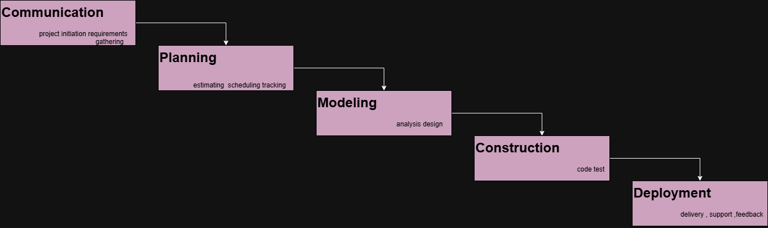

Testing:
- Unit Testing – Verified individual features like login, income entry, and expense tracking
- Integration Testing – Ensured modules (e.g., dashboard + transaction logic) work together smoothly
- System Testing – Checked the full app workflow from login to balance updates
- User Acceptance Testing – Confirmed that the app meets expected functionality and is easy to use
Expected Result: The system should accurately store data, calculate totals, and generate correct results.

Future Enhancements:
- Integration with online banking.
- AI-based budget suggestions.
- Cloud synchronization for multiple devices.
- Multi-user collaboration (e.g., family budgeting).
- Alert & notification.
- Budget plan.
- Analysis graph charts.

Conclusion:
MoneyTrail is a lightweight, intuitive finance tracker built for real-life money habits. With editable entries and real-time balance alerts, it replaces messy notebooks and forgotten expenses with clean, mobile-first control. It’s not just about tracking—it’s about staying aware, organized, and one step ahead.

